

American International University-Bangladesh (AIUB)  
**Department of Computer Science  
Faculty of Science &Technology (FST)  
Spring 20_21  
CSC 2210 Object Oriented Analysis and Design (OOAD)**

**Section:   
Group No:**

**PROJECT TITLE**

An Object-Oriented Analysis and Design (OOAD) project submitted

By

|  |  |  |
| --- | --- | --- |
| Serial No. | Student Name | Student ID |
|  |  |  |
|  |  |  |
|  |  |  |
|  |  |  |

The project will be Evaluated for the following Course Outcomes

|  |  |
| --- | --- |
| **Project Marks Distribution** | Total Marks |
|  |
| Sequence Diagram [5Marks] |  |
| Activity Diagram [5Marks] |  |
| State Diagram [5Marks] |  |
| Submission, Completeness, Spelling, Grammar and Organization [5Marks] |  |

## Sequence Diagram

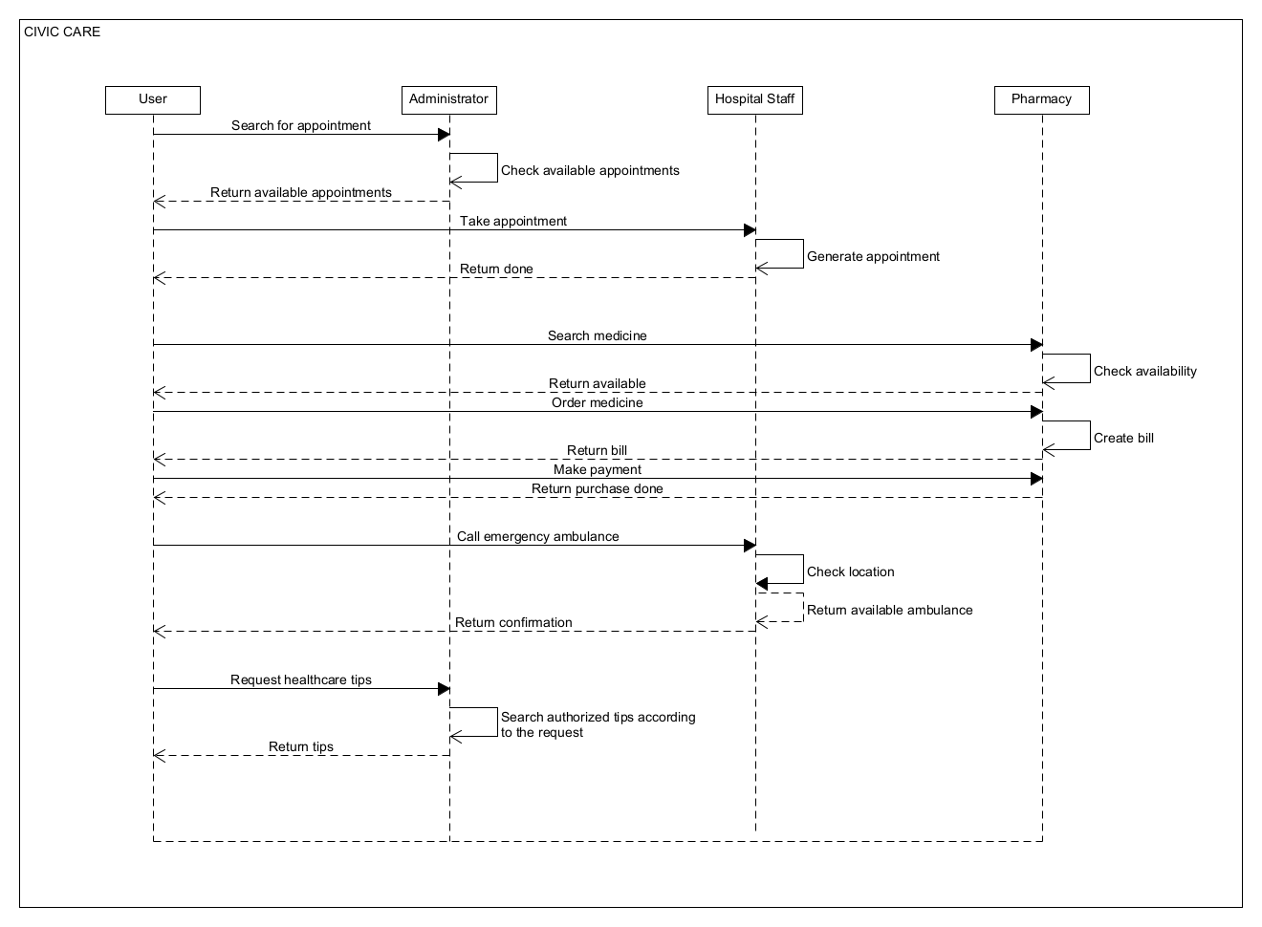

* Does the sequence narrative represent the Scenario of the sequence diagram?

In this system, when the user wants to schedule an appointment with the doctor, first the user will search for an appointment through the administrator. Then the administrator will check available appointments and will return available appointments to the user. After that, the user will take the best appointment for him through the hospital staff. The hospital staff then generate an appointment and return the appointment schedule to the user. On the other hand, when the user wants to buy medicine, first the user will search for medicine through pharmacy. Pharmacy will check the availability of the medicine and if available then it will return available to the user. After that the user can order the medicine from pharmacy and pharmacy will create a bill and return the bill to user. When user makes payment to the pharmacy then the pharmacy will return the purchase done to the user. Also, in this system, the user can call for an emergency ambulance through hospital staff. When hospital staff gets a call from user, they will check location. If there is an available ambulance for that location, they will return confirmation to user. Lastly, a user can request healthcare tips to administrator in this system. After getting the request, the administrator will search for authorized tips according to the request and will return the tips to user. This sequence narrative represents the scenario of the above sequence diagram.

* Does the Sequence diagram include the sequence of the major activities needed to deliver by the system?

Yes, the sequence diagram includes the sequence of the major activities needed to deliver by the system.

## Activity Diagram

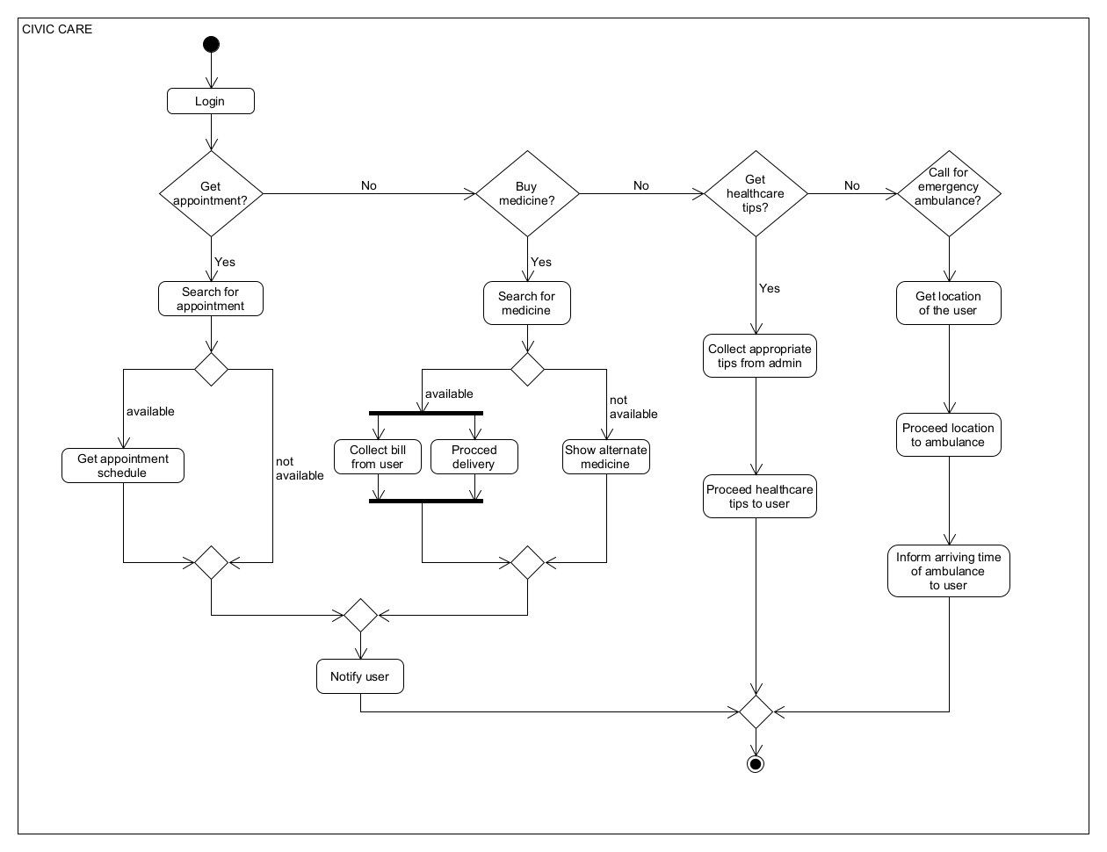

* + Does the activity narrative represent the Scenario of the activity diagram?

In this system, a user has to log in to get access to the system. A user can get appointment with renowned doctors, buy medicine, get healthcare tips and call for an emergency ambulance through the system. If a user wants to get an appointment through the system, then the system will search for the appointment. If there is any appointment available according to the request of the user, then the system will get the appointment schedule from the hospital and notify the user about the schedule and if there is not any available appointment, it will also be notified to user by the system. On the other hand, when user wants to buy medicine, the system search for the medicines. If the medicine is available, the system collects bills from user for the medicines and proceed the medicine delivery by notifying user which is done simultaneously. If the medicine is not available, the system shows alternate medicine to the user and notifies the user. When user wants to get healthcare tips, the system collects appropriate tips from the admin and proceeds the healthcare tips to the user. Lastly, a user can call for emergency ambulance service through the system. When user calls for an emergency ambulance, the system gets the location of the user and proceeds the location to the ambulance, and then user is informed of the arrival time of the ambulance. This activity narrative represents the scenario of the above activity diagram.

* Does the Activity diagram include the major activities needed to deliver by the system?

Yes, the activity diagram includes the major activities needed to deliver by the system.

## State Diagram

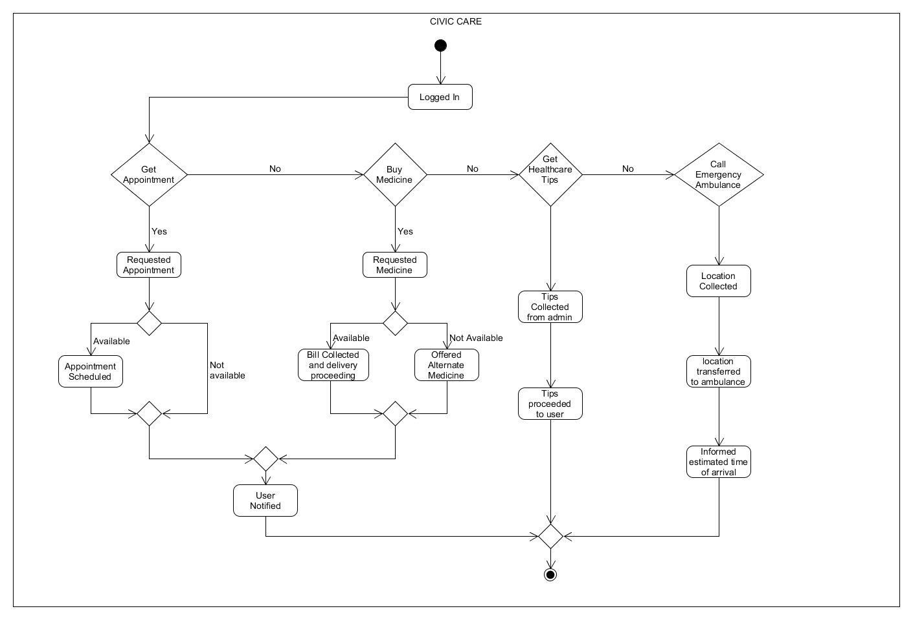

* + Does the state narrative represent the Scenario of the state diagram?

In this system, when the user logs in, it is in logged-in state. If the user wants to get an appointment then he will request an appointment which will be in requested state. If there is an appointment is available then the appointment will be scheduled and it will be in the appointment scheduled state. After that user will be notified about the schedule and it will be in user notified state. If the appointment is not available then user will also be notified about this and it will be in user notified state. On the other hand, if user wants to buy medicines then user will request to buy medicine and it will be in the requested state. If the requested medicines are available then bill will be collected as well as delivery will proceed and it will be in bill collected and delivery proceeding state. After this, the user will be notified. If the medicines are not available then the system will offer alternative medicine and it will be in offered alternate medicine state which will also be notified to the user. When the user wants to take healthcare tips then the system will take tips from the admin and it will be in tips collected state. After collecting the appropriate tips it will proceed to the user and it will be in proceeded state. Lastly, the user can also call for emergency ambulance service through the system and when the user does this system collects the user’s location and it will be in location collected state. After collecting location it will be transferred to the ambulance authority and it will be in location transferred state. After that, the user will be notified about the estimated time of arrival of the ambulance and it will be in informed state. This state narrative represents the scenario of the above state diagram.

* Does the state diagram include the major states needed to deliver by the system?

Yes, the state diagram includes the major states needed to deliver by the system.

**Text Format**

* Style: Times New Roman
* Size: 12
* Alignment: Justify
* Line Spacing: 1.00
* Length: Maximum 4 pages